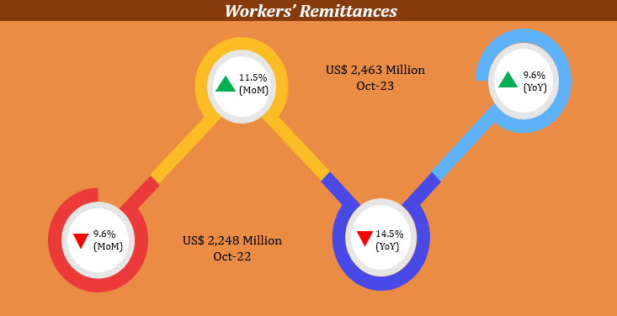
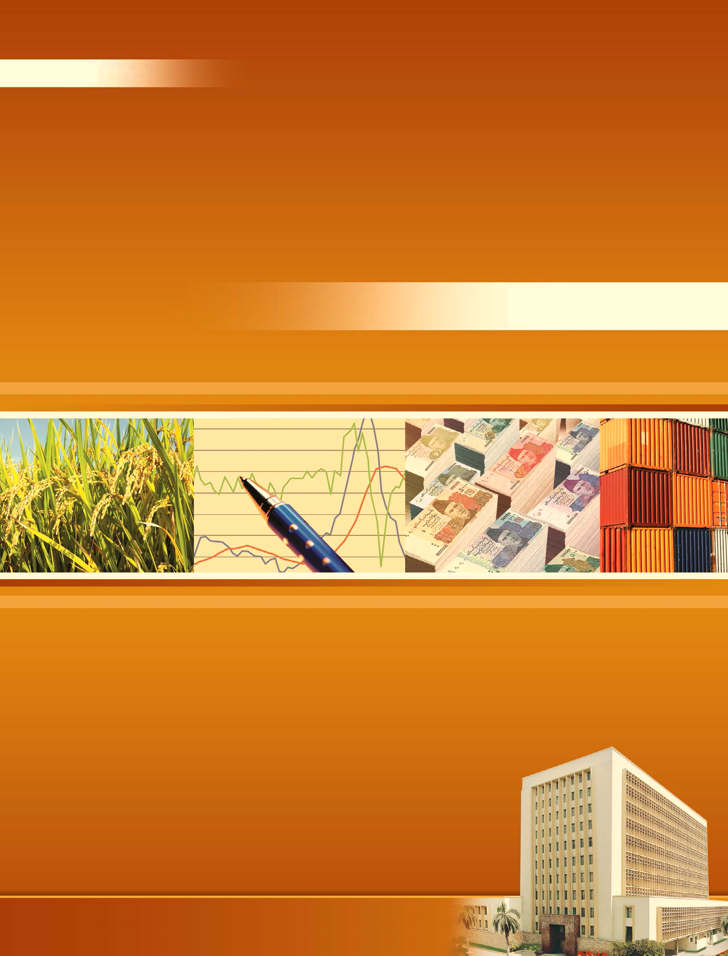
November 2023
DATA SERVICES AND INNOVATIONS DEPARTMENT
STATE BANK OF PAKISTAN
Statistical
Bulletin
Monthly

